1. This problem involves hyperplanes in two dimensions.

1. Sketch the hyperplane 1 + 3X1-X2 = 0. Indicate the set of points for which the formula is >0 and <0.
2. On the same plot, sketch the hyperplane -2+X1+2X2 = 0. Indicate the points again.

**Answer**:

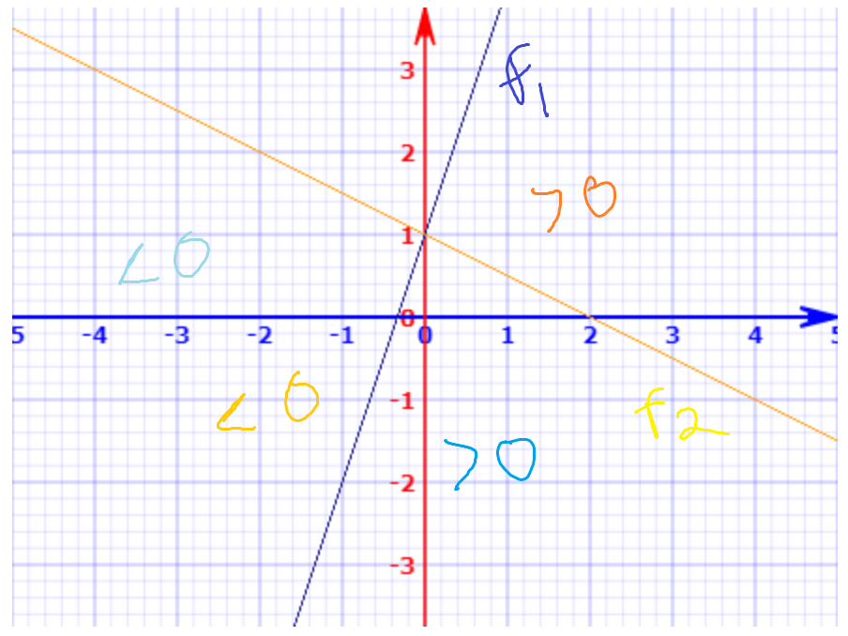

2. We now investigate a nonlinear line

1. Sketch (1+X)2 + (2-y)2 = 4

**Answer**:

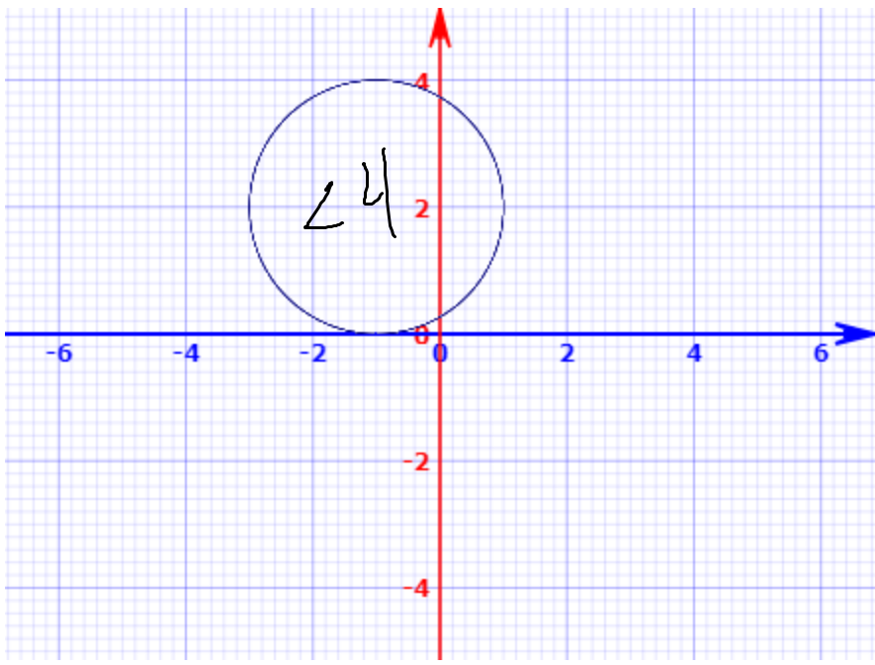

1. Indicate which points are greater than 4 and less than or equal to 4.
2. Assuming blue is >4 and red otherwise, which class do the following points belong to
   1. (0, 0) - **Answer**: Blue
   2. (-1, 1) - **Answer**: Red
   3. (2, 2) - **Answer**: Blue
   4. (3, 8) - **Answer**: Blue

3. Here we explore the maximal margin classifier on a toy dataset

1. We are given the following observations:

|  |  |  |  |
| --- | --- | --- | --- |
| 1 | 3 | 4 | Red |
| 2 | 2 | 2 | Red |
| 3 | 4 | 4 | Red |
| 4 | 1 | 4 | Red |
| 5 | 2 | 1 | Blue |
| 6 | 4 | 3 | Blue |
| 7 | 4 | 1 | Blue |

For each observation there is an associated class label. Sketch the observations

**Answer**:

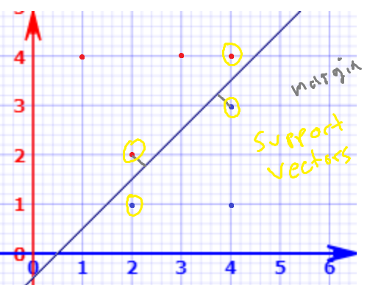

1. Sketch the optimal separating hyperplane and provide the equation

**Answer**: Line will go through (2, 1.5) and (4, 3.5) which implies the formula is

X1-X2-0.5 = 0

1. Describe the classification rule

**Answer**: When the equation is <0 classify as Red, otherwise Blue

1. Indicate the margin on the sketch

**Answer**: The margin is the perpendicular distance to the point from the line. Using geometry, one can show that the margin is $\sqrt{0.5}$.

1. Indicate the support vectors
2. Why would a slight movement of the 7th observation not matter?

**Answer**: Because it is not a support vector

1. Sketch a hyperplane that is not the optimal separating hyperplane and provide its equation.

**Answer**: Didn’t sketch, but one possible answer would be shifting the line up by 0.2, so that the equation would be X1-X2-0.3 = 0. This would make the margin smaller for red points.